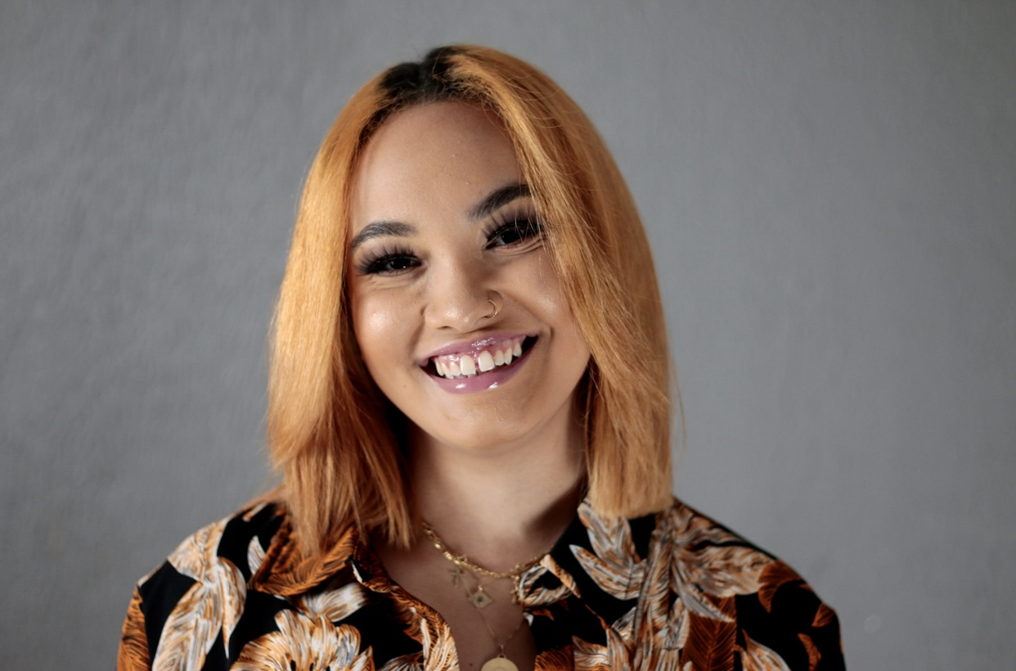 |  | Abia  Harper  Marketing Administrator  At JB Entreprises S.C. Law & Strategy
Contact  PHONE:  414-748-2242  EMAIL:  harper.abia@gmail.com  Volunteer  Signature Dance Company  - Camp Facilitator  - Stage Manager  Christian Faith Fellowship Church  - Children’s Ministry  Rufus King High School  - Team Manager (Basketball & Football)  Official Election Inspector  - 2016 Presidential Election |  | EDUCATION  Marquette University  Jan 2020 – May 2020  Enrolled in the School of Sociology with a minor in Marketing entering my Junior Year  University of San Francisco  August 2018 – December 2019  Enrolled in the School of Marketing with a minor in Sociology  WORK EXPERIENCE  JB Entreprises – Marketing Administrator  January 2021 – Present  - Marketing/Social Media Manager  - Marketing content creator  - Designing and developing marketing content for the firm  A Rye Inc. / Impact Strategies – Media Cohort Intern  July 2021 – Present  - Intern for Angela Rye and Impact Strategies’ social media platforms  - Created graphics weekly that were distributed to her 1.5 million followers  - Kept up with and implemented social media content calendars  Employ Milwaukee – Youth Intern  August 2020 – January 2021  - Office administration  - Conducted orientations with employees  - Created Excel spreadsheets for data tracking  Milwaukee Radio Group – Promotions Staff  June 2019 – March 2020  - Offsite event coordination and set up  - Radio representation with customers at Live onsite events  - Handled social media content at onsite events for all radio stations  SKILLS

